📄 YD-310CC / YD-418CC / YD-428CC
🖼️Product Overview
Fig. 1: Full View  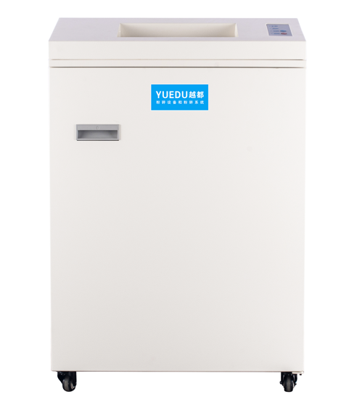 | Fig. 2: Feeding View  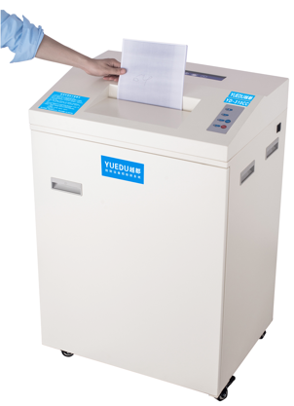 | Fig. 3: Internal View  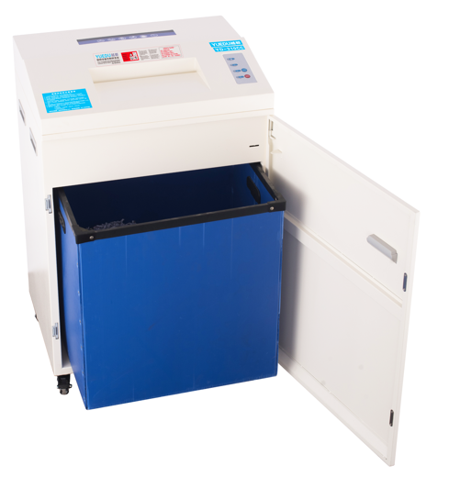
✅ Key Features

● 🔁 Continuous operation over 3 hours
● 🗑️ 150L BIN
🔧 Technical Specifications:
🆔Model | YD-310CC | YD-310CCM | YD-418CC | YD-428CC | 图4 YD-418CC机型碎图纸  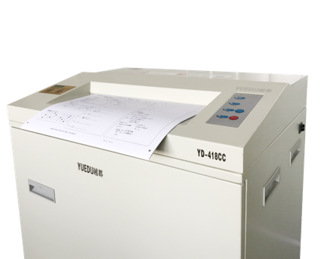
📥Feed Width | 310mm | 310mm | 418mm | 428mm
✂️Cut Size | 3.8*39mm | 1.9*15mm | 3.8*39mm | 5.8*45mm
📑Max Sheets | 25-35 | 16-20 | 25-32 | 55-65
⚖️Weight | 93kg | 95kg | 97kg | 110kg
🔌Power | 1.2KW | 1.2KW | 1.3KW | 2KW | 图5 YD-428CC整机图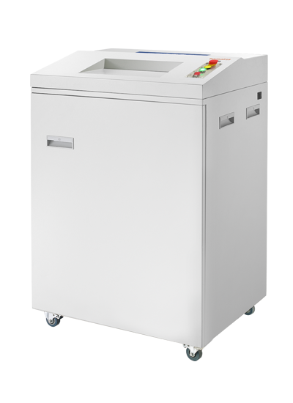
🔁 Continuous | 3 hours | 3 hours | 3 hours | Continuous
📏 L×W×H (mm) | 620*480*1070mm | 620*480*1070mm | 620*480*1070mm | 800*650*1150mm
🗑️Bin(L) | 150L | 150L | 150L | 260L
💰Price (USD) | 18800元 | 19800元 | 28140元 | 37750元

